System Interface Specification – SIS
for
Water Intelligent Network Management System (INMS)
of the
Water Supplies Department (WSD)
Version: 0.97

June 2019
© The Government of the Hong Kong Special Administrative Region

The contents of this document remain the property of and may not be reproduced in whole or in part without the express permission of the Government of the HKSAR

Distribution
Copy No. | Holder
1 | Water Supplies Department
2 | GDHK (Shenzhen Yuegang Technology Co.Ltd.)

Amendment History
Revision Number | Description | Sections affected | Modified By | Date
0.9 | First Draft | [---] | CSA/AM (WSD) | 23 May 2019
0.95 | Clarify with user that only one record per date is required.  Miscellaneous minor modification | [---] | CSA/AM (WSD) | 3 June 2019
0.96 | Miscellaneous minor modification in table of section 4.3.1 and 4.3.2  Add remark in Page 12 | 4.3.1  4.3.2  Page 12 | CSA/AM (WSD) | 4 June 2019
0.97 | Provide more examples for API “I-SIS-001” (returned JSON content include “Unit” information) | Page 10 | CSA/AM (WSD) | 26 June 2019

Prepared By: | Endorsed By:
Project Manager (GDHK) | Project Director (GDHK)
Date: | Date:

TABLE OF CONTENTS

1. Overview 5
2. Definitions and Conventions 6
2.1 Definitions 6
2.2 Conventions 6
3. System Interface 7
3.1 Interface with SIS 7
4. Interface with SIS 8
4.1 Flow Diagram 8
4.2 List of Interfaces 8
4.3 Interface Definition 8

Overview
A new system, named “Water Intelligent Network Management System” (INMS) is designed as a central repository, collecting data from DMA/PMAs (including flowmeters and data loggers), and records from several IT systems of WSD such as DMS, CCBS, MWMS, MGIS, DIP, etc. Apart from determining the water loss and the water balance, the System needs to derive meaningful and actionable information after analysis of the data in order to identify irregularities including leakage trends, potential unauthorized water consumption, etc. and to formulate, prioritize and implement follow-up actions including investigation for unauthorized consumption, active leakage control, asset replacement works with the aim of reducing the water loss.

Currently, WSD is managing three separate water supply and distribution networks for fresh water, raw water and flushing water supplies respectively. While DMAs and PMAs are only applied to the fresh water supply and distribution network, the System shall be used to manage the three water supply and distribution networks.

A detailed description of the system interface for SCADA (through SIS) is presented in this document.

Definitions and Conventions

Definitions
None

Conventions
WSD | Water Supplies Department
GDHK | Shenzhen Yuegang Technology Co.Ltd.
INMS | Water Intelligent Network Management System
DIP | Departmental Information Portal
DMS | Digital Mapping System
MGIS | Mobile Geographic Information System
MWMS | Maintenance Works Management System
CCBS | Customer Care and Billing System
SIS | SCADA Information System
AMRMS | Automatic Meter Reading Master Station
RTMDLS | Real-time Monitoring Data Logging System
TDL | Telemetry Data Logger
Cello | Technolog Limited’s products
PMAC | Pressure Monitoring and Control
i2O | i2O Water Ltd
CSL | CSL Mobile Limited

System Interface

Interface with SIS

The System shall be able to interface with the SCADA Information System (SIS) to receive monitored data such as flow, pressure and level of the fresh water, raw water and flushing water supply and distribution systems. Data is to be loaded and updated on at least hourly basis with 15-minute interval or higher frequency time interval. (Remark: After further clarification with end user, for each tag of SCADA, only one record per date is required to be retrieved through this interface under normal situation).

The SIS is a WSD Intranet application that connects to and retrieves data (mainly historical) from the SCADA system. The SCADA system gathers operational data (e.g. service reservoir levels, flow rates and accumulated flow) of WSD. SIS offers a read-only interface to an authenticated third party through a RESTful application programming interface.

Interface with SIS

Flow Diagram
This section is left blank intentionally

List of Interfaces
Interface ID | Interface Name | Related Requirements
I-SIS-001 | Issue call to SIS3 (through RESTful API) to retrieve data of SCADA  (Return one record) | [---]
I-SIS-002 | Issue call to SIS3 (through RESTful API) to retrieve data of SCADA  (Return multiple records) | [---]

Interface Definition

I- SIS-001: Issue call to SIS3 to retrieve data of SCADA (Return one record)
Interface ID | I-SIS-001
Interface Name | Issue call to SIS3 to retrieve data of SCADA (Return one record)
Description | Issue call to SIS3 to retrieve data of SCADA, to receive monitored data such as flow, level of different “Tags”. (A full list of tags will be provided by WSD)
Frequency | Issue call daily started from 1:00am, and repeat API call until data of all “Tags” have been retrieved. Each call will retrieve data closest to the specified date/time (eg: 9:00am of previous day)
Mode | API function
Protocol | HTTPs (RESTFul API)  (Remark: Server certificate is self-signed (ie: DON’T verify the CA))
Direction | Call from INMS (Prod Site: EMSD KBO Data Center) to SIS (Prod Site : WSD LCRW – “Lung Cheung Road Workshop”)
Security | SIS server will white list IP address of INMS server  (Remark: IP address 10.66.xx.xx was enabled to allow testing by ITMU during SA&D, and will be disabled while INMS server has been setup)
Retry Mechanism | Nil  (Remark: Please note that data are permanently stored in database. If the SIS3 web server is unreachable for any reasons, when it comes on again INMS can issue this API for the missing data, which may be recoverable)
Estimated Size | Each API call will return 1 record with size of around 300 Bytes
Housekeeping | Nil  (Remark: Records returned by the API call will be processed and saved to INMS database, and will not be saved as physical file in server)
Constraints | [---]

Functional Description
Below please find syntax of API call provided by SIS3.
For a typical flow
[Example 1]
https://wiki.sis2.wsd.gov/sis3/webresources/history/realflex6/HKI/SANDYBAY_PS/M/CIPS0QMI3F1?type=nearest&time=2019-06-26T09%3A00%3A00%2B08%3A00
Remark: Type = before | nearest | after
%3A (:)
%2B (+)
Accept : Application/Json
/M/ : Meter (Flow), /A/ : Analog (Level), /S/ : Status
Content returned in JSON format
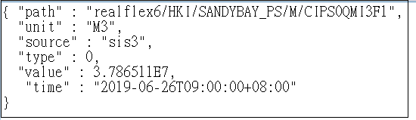
[Example 2]
https://wiki.sis2.wsd.gov/sis3/webresources/history/realflex6/HKI/SANDYBAY_PS/M/CIPS0QMI1F1?type=nearest&time=2019-06-26T09%3A00%3A00%2B08%3A00

Content returned in JSON format
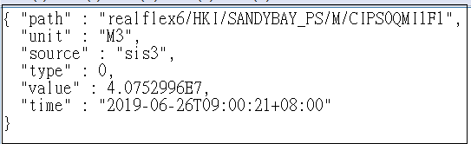
[Example 3]
https://wiki.sis2.wsd.gov/sis3/webresources/history/realflex6/HKI/SEVERN_RDPS/M/CIPS0QF03?type=nearest&time=2019-06-26T09%3A00%3A00%2B08%3A00
Content returned in JSON format
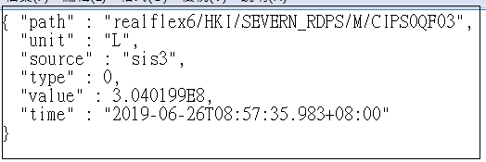
[Example 4]
https://wiki.sis2.wsd.gov/sis3/webresources/history/realflex6/KLN/CKL_SWPS_PM/M/CIFK0QF00?type=nearest&time=2019-05-01T09%3A00%3A00%2B08%3A00
Content returned in JSON format
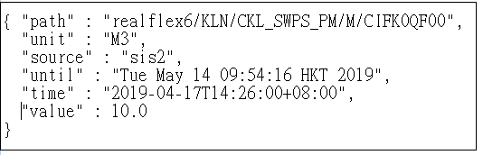
Remark:
- Only need to retrieve “flow information” (ie: level and status is not required by INMS)
- INMS will use this API to retrieve “flow information” which is closest to 9:00am of previous day, information will be retrieved daily.
- For example 4 above, as data of the tag was imported to sis3 since 14 May 2019. If API specify an earlier time, sis3 will look up the historical data from sis2.

I- SIS-002 : Issue call to SIS3 to retrieve data of SCADA (return multiple records)
Interface ID | I-SIS-002
Interface Name | Issue call to SIS3 to retrieve data of SCADA (return multiple records)
Description | Issue call to SIS3 to retrieve data of SCADA, to receive monitored data such as flow, level of different “Tags”.
Frequency | Issue call in Ad Hoc mode while required (eg: for particular report).  Each call will retrieve data of one day (eg: from 2019-05-01 00:00:00 to 2019-05-02 00:00:00)  (Remark: As it may cause lengthy query time, suggest don’t issue this API with duration of more than 1 day)
Mode | API function
Protocol | HTTPs (RESTFul API)  (Remark: Server certificate is self-signed (ie: DON’T verify the CA))
Direction | Call from INMS (Prod Site: EMSD KBO Data Center) to SIS (Prod Site : WSD LCRW – “Lung Cheung Road Workshop”)
Security | SIS server will white list IP address of INMS server  (Remark: IP address 10.66.xx.xx was enabled to allow testing by ITMU during SA&D, and will be disabled while INMS server has been setup)
Retry Mechanism | Nil  (Remark: Please note that data are permanently stored in database. If the SIS3 web server is unreachable for any reasons, when it comes on again INMS can issue this API for the missing data, which may be recoverable)
Estimated File Size | Total size will depend on number of records returned. Each record with size of around 70Bytes.
Housekeeping | Nil  (Remark: Records returned by the API call will be processed and saved to INMS database, and will not be saved as physical file in server)
Constraints | Assume each API call try to retrieve records of 1 day, using this method to get “level” is good, but not for getting “flow” (because 5-6 API calls are required to retrieve all records of 1 day)

Functional Description
Below please find syntax of API call provided by SIS3.
For a typical flow
https://wiki.sis2.wsd.gov/sis3/webresources/histories?tag=realflex6/NTE1/HAHANG_FWSR/M/CISR0QF01&from=2019-03-01T00:00:00%2B08:00&to=2019-03-02T00:00:00%2B08:00

For a typical level
https://wiki.sis2.wsd.gov/sis3/webresources/histories?tag=realflex6/NTE1/HAHANG_FWSR/A/AISR1LL01&from=2019-03-01T00:00:00%2B08:00&to=2019-03-02T00:00:00%2B08:00
Remark:
- Client IP will be white listed and restricted to server of INMS only
- "to" must be later than "from"
- “Tag” must exist (eg: NTE1/HAHANG_FWSR/M/CISR0QF01)
- A maximum of 500 results will be given. This number (500) can be tuned for best performance. The result has an attribute called "all-count" (near the end of the JSON result), which is the ACTUAL number of histories for that period. If that is larger than 500, you can issue a second request with a "from" time right after the first request's "to" time.

Using this method to get “level” is good, but not for getting “flow”. The result of the first request (for flow) yields data from 00:00 to 07:56 and an "all-count" of 3085, a total of 6 requests is needed for the entire day.

- Due to the large data size and limited computing resources, retrieval time can be slow at times. However, the database caches queries and the data are indexed on tag+time. Therefore it will be much more efficient if data is queried for the same tag over a longer period, than to hop around 300 tags with 300 queries each one retrieving one single record.
[Sample of API call and return JSON content]
Example 1: Outflow
https://wiki.sis2.wsd.gov/sis3/webresources/histories?tag=realflex6/HKI/HARCOURT_PS/M/CIPS0QMD1F1&from=2019-05-01T00:00:00%2B08:00&to=2019-05-02T00:00:00%2B08:00
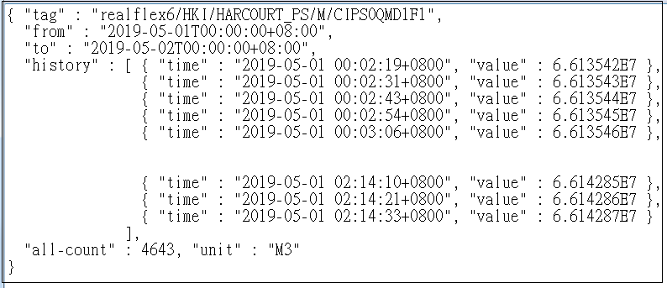
Remark:
- “E” means exponential (ie: “6.613542E7” means 6613542)
- Unit is "M3" (ie: flow count (volume), similar to home's water meter) instead of "M3/h"
- Above records show the flow count shown on the meter at the time of viewing. For total flow in a period, subtract the two consecutive values.

Example 2: API call but without sampling record
https://wiki.sis2.wsd.gov/sis3/webresources/histories?tag=realflex6/HKI/HARCOURT_PS/M/CIPS0QMD2F1&from=2019-05-01T00:00:00%2B08:00&to=2019-05-02T00:00:00%2B08:00
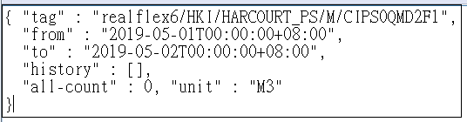
Example 3 : InFlow
https://wiki.sis2.wsd.gov/sis3/webresources/histories?tag=realflex6/HKI/WC_ICCP_KSK/M/CIFK0QM1F1&from=2019-05-01T00:00:00%2B08:00&to=2019-05-02T00:00:00%2B08:00
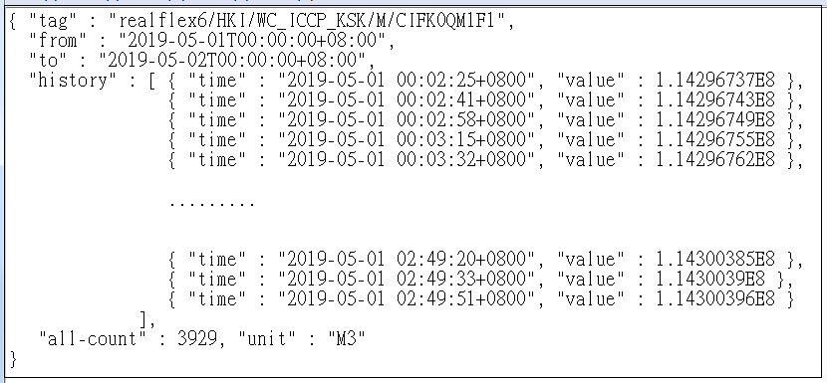

Example 4 : Level
https://wiki.sis2.wsd.gov/sis3/webresources/histories?tag=realflex6/NTE1/HAHANG_FWSR/A/AISR1LL01&from=2019-03-01T00:00:00%2B08:00&to=2019-03-02T00:00:00%2B08:00
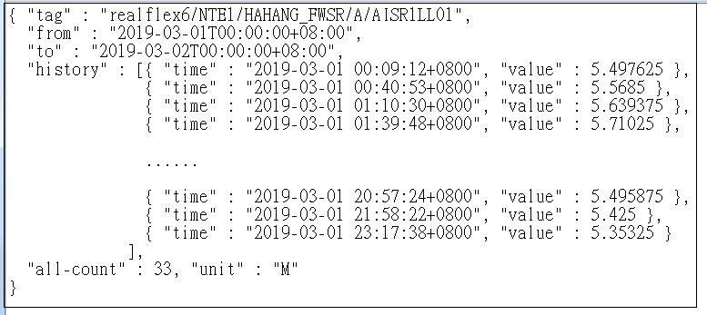

Example 5: API call but with invalid Tag
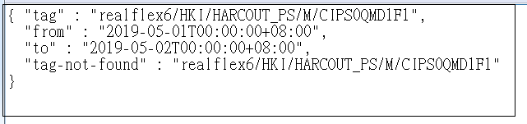
Remark
For system administration purpose, suggest to display result of the interface through web UI as shown below.
